**Daily Schedule**

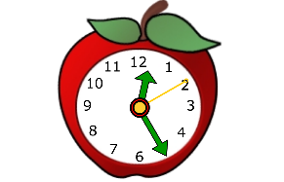

**8:00-8:30** – 5th Grade Inclusion (ELA)

**8:30-9:00-** 4th Grade Inclusion (ELA)

**9:00-9:30-** 3rd Grade Inclusion (ELA)

**9:30-10:00-** 5th Grade Inclusion (Math)

**10:00-10:30-** 4th Grade Inclusion (Math)

**10:30-11:00-** 3rd Grade Inclusion (Math)

**11:00-11:40** (Pull-out Math, Writing)

**12:00-12:30**- Lunch

**12:30-1:00-** Planning

**1:00-1:40-** (Pull-out Reading)

**2:00-2:30-** (Pull-out Reading)

**2:30-3:00-** (Pull-out Math)

**3:00-3:20-** Social Emotional Skills